Library Topic : Library Management System(using tkinter)

**How to run the code :**

1. RUN the program by executing 'login_register.py' provided all other files should also be present in the same directory
2. To login as Librarian or Student, click on the desired button on top of the window.
3. Default Libraian username='admin' and password='admin'.
4. For Student, user have to first SignUp to fill his/her credentials then he/she can login into the student window through the registered name and password and proceed further.

Team Member :

1.Hasti Shah (1811043)

2.Nishi Shah (1811045)

Description :

The library management system is a desktop application which has two section ,i.e., Librarian section and student section .

Libraries used :

* tkinter : for GUI
* Sqlite3: for database connection

Software used :

* Visual studio code : To write code
* DB browser(SQlite) : To connect with database

Screenshots:

The username and password for librarian is admin .

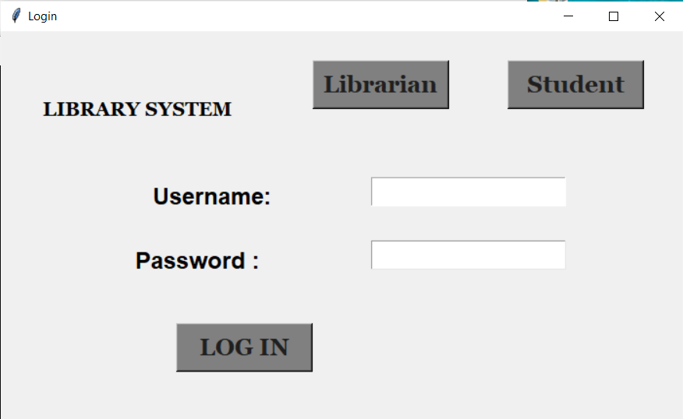

Student’s can login with personal details such as name and password .

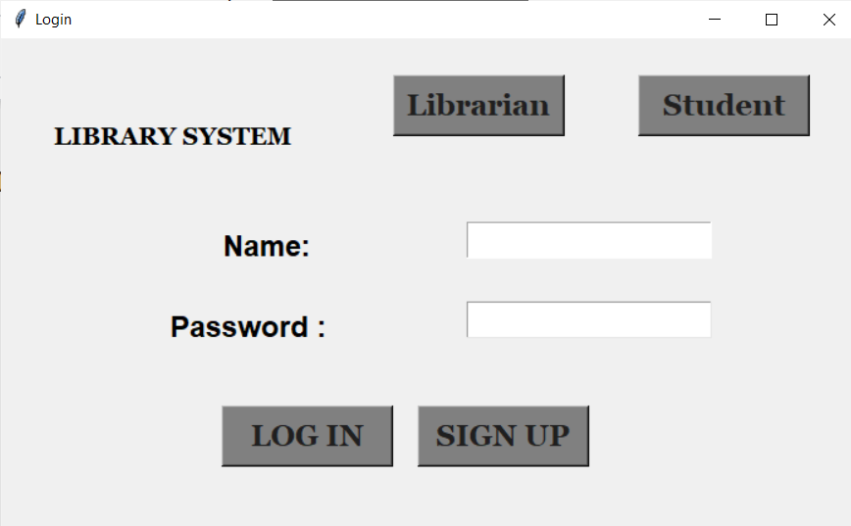

If any particular student has not login before , then he/she can sign up by filling details such as name and roll no .

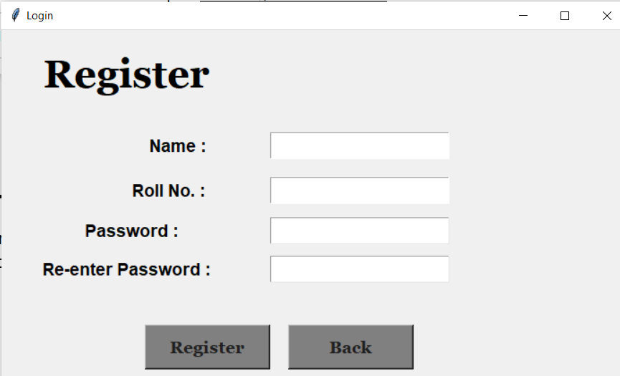

Librarian Section :

From this page , librarian can add , search , delete and update books which are available in the library .The librarian can also see the list of books available at the present .

Functions that can be done by librarian side :

* View all
* Search
* Add entry
* Update entry
* Delete

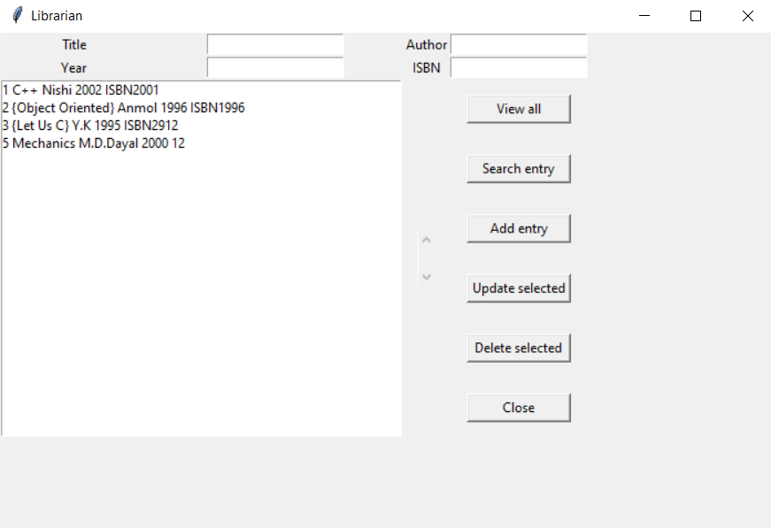

Student’s section :

Students can issue , request ,search and view all the books available in the library after login .

Function that can be done by students side :

* View
* Search
* Issue
* Request

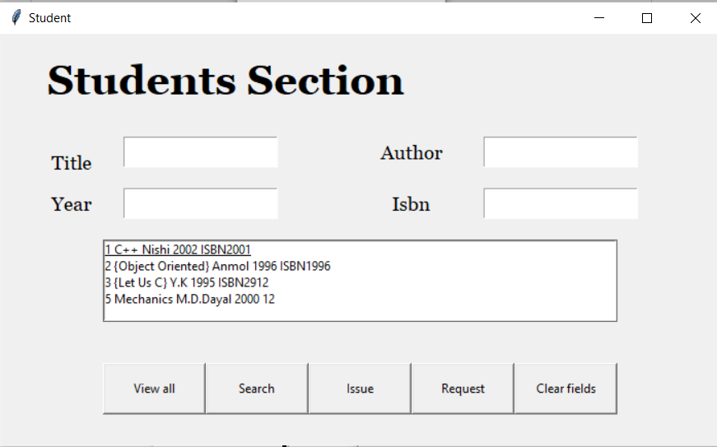

Database :

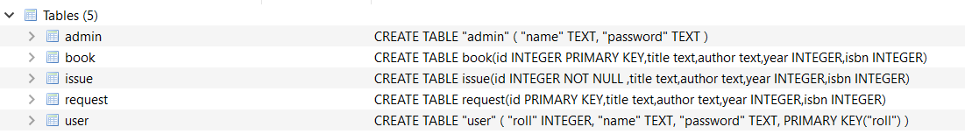

Admin db table :

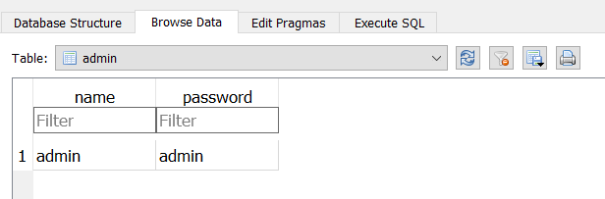

Book db table :

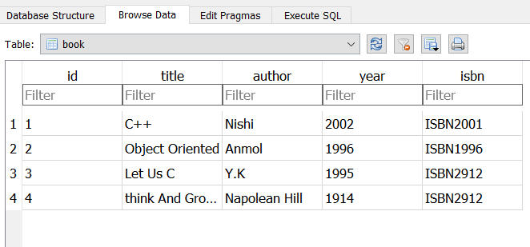

Issue db table :

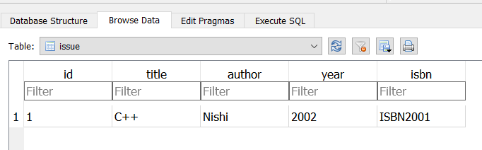

Students(User) db table:

